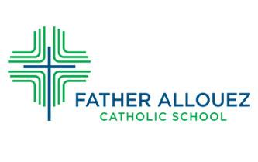
Kindergarten Curriculum
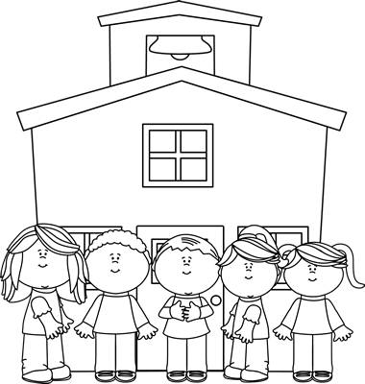

Religion
Kindergarten uses the “New Evangelization Edition” of Christ Our Life. Each lesson in the program flows from the words of Jesus Christ in the Sunday Gospels.

Kindergarteners attend weekly Mass and take part in other schoolwide prayer opportunities. Our faith is a part of everything we do.

The main themes of the Kindergarten religion program are:

Learning About God’s Love
- Jesus Welcomes Us Through Others
- Jesus is God’s Son/We Honor Jesus
- We Care For God’s World
- We Meet God Through Prayer
Growing in God’s Love
- We Belong to God’s Family
- God Makes Us Wonderful
- We Give Thanks to God
- We Prepare Through Prayer
Sharing God’s Love
- Jesus is Our Shepherd
- Jesus Loves/We Are Loved
- Jesus Helped People/We Can Help Others
- Jesus Forgives Us/We Forgive Those Who Have Hurt Us
Celebrating God’s Love
- The Cross is a Sign of Jesus’ Love
- We Celebrate New Life
- The Light of Jesus Shines in Us
- The Mass is a Celebration

Math
- The Kindergarten Math curriculum is guided by our GRACE Power Standards for Math, in conjunction with Math Expressions. We use a collaborative approach to Math. Many of the activities are small group hands-on activities. Kids are encouraged to use ‘math talk’ in which they describe what they are doing and thinking to help themselves and others learn the process. Power Standards are a subset of learning standards that educators have determined to be the highest priority or most important for students to learn.

Scope of the Kindergarten Math Curriculum:

Patterns | Graphs
Skip Counting by 2’s, 5’s, 10’s | Shapes
Addition and Subtraction to 10 | Fractions
Money | Measurement
Number Order | Calendar
Number Recognition | Time
Number Value | Story Problems

- Within these units are standards and power standards. Standards are concepts that are introduced but are not required to be mastered in kindergarten. Power Standards are the ‘must knows’ of kindergarten math. The goal is to teach the Power Standards to mastery to ensure success in future grades.

Language Arts

- Phonics, reading and writing are all components of our kindergarten language arts curriculum. These areas are crucial in helping a child build important literacy and communication skills. The items below make up our LA program:

Phonics:
Fundations® is a multisensory and systematic phonics, spelling, and handwriting program. In Kindergarten Fundations® works on:
- Letter/Keyword/Sound for all 26 letters of the alphabet and 5 digraphs
- Lowercase and uppercase letter formation
- Decoding - tapping letters out to read words
- Encoding - isolating sounds to spell words
- Learning high frequency words
- Introduction to digraphs
- Sentence formation
- Alphabetical order
- Retelling stories

Reading:
- Guided Reading is another component of the Kindergarten Language Arts Program. Books from level aa - M are used in the kindergarten classroom to provide individual or small group instruction. In November, children will be assessed through fountas and pinnell and assigned a Guided Reading Level based on word knowledge, comprehension and fluency. Most kindergarten students begin at a level aa or A with a goal of reaching level D by the end of the school year.

Guided Reading groups are flexible and change as each student progresses at their own speed.

- Fountas and Pinnell Reading Mini Lessons are short explicit lessons about reading principles that students can apply to their own independent reading.

Writing:
This year we are introducing the Lucy Calkins program to our writing curriculum.
- We will begin with writing by drawing and labeling and by the end of the year students will be writing full sentences!

Sight Word recognition is another important component of the Language Arts Program. Sight words are high frequency words - words that most commonly appear in the text of early readers. These words make up a core set of vocabulary that children need to learn in order to read quickly and automatically. Our sight words are taken from the Fry List of words.

Social Studies:
McGraw Hill Impact Social Studies - Learning and Working Together
- Good Citizens
- Where Do We Live?
- Our Country
- Life Long Ago and Today
- All About Work

Science:
Science is taught through ‘Einstein Kits’. This year’s Einstein Kits are Weather,
Force & Motion, and Plants. These kits help us to go in depth and learn hands-on science. They are interactive units that keep the kids engaged and excited about science concepts. The kids work together to learn and solve problems.

Specials Classes:
- Spanish
- Art
- Phy Ed
- Music
- Guidance
- Library
- Technology

Extras
- Birthday and Half Birthday Celebrations
- Show and Share
- Super Hero of the Week
- Holiday Parties
- Christmas Nativity Play
- Participate in All-School Christmas Program
- Catholic Schools Week Celebration
- 100 Days of School Celebration
- Pajama/Hibernation Day
- Dr. Seuss's Birthday
- Art Fair
- Talent Show
- Weekly Mass, Mass-Planning/Participation
- Divine Mercy Chaplet/Rosary Monthly
- Vocations Day/Discovery Day
- Field Day

Revised 9/10/21

